- Home Page
- I would like the menu bar fixed when the customer is scrolling up or down (same as freeze pane function in excel)
- Is it possible to move the logo to the left-hand side on the menu bar?
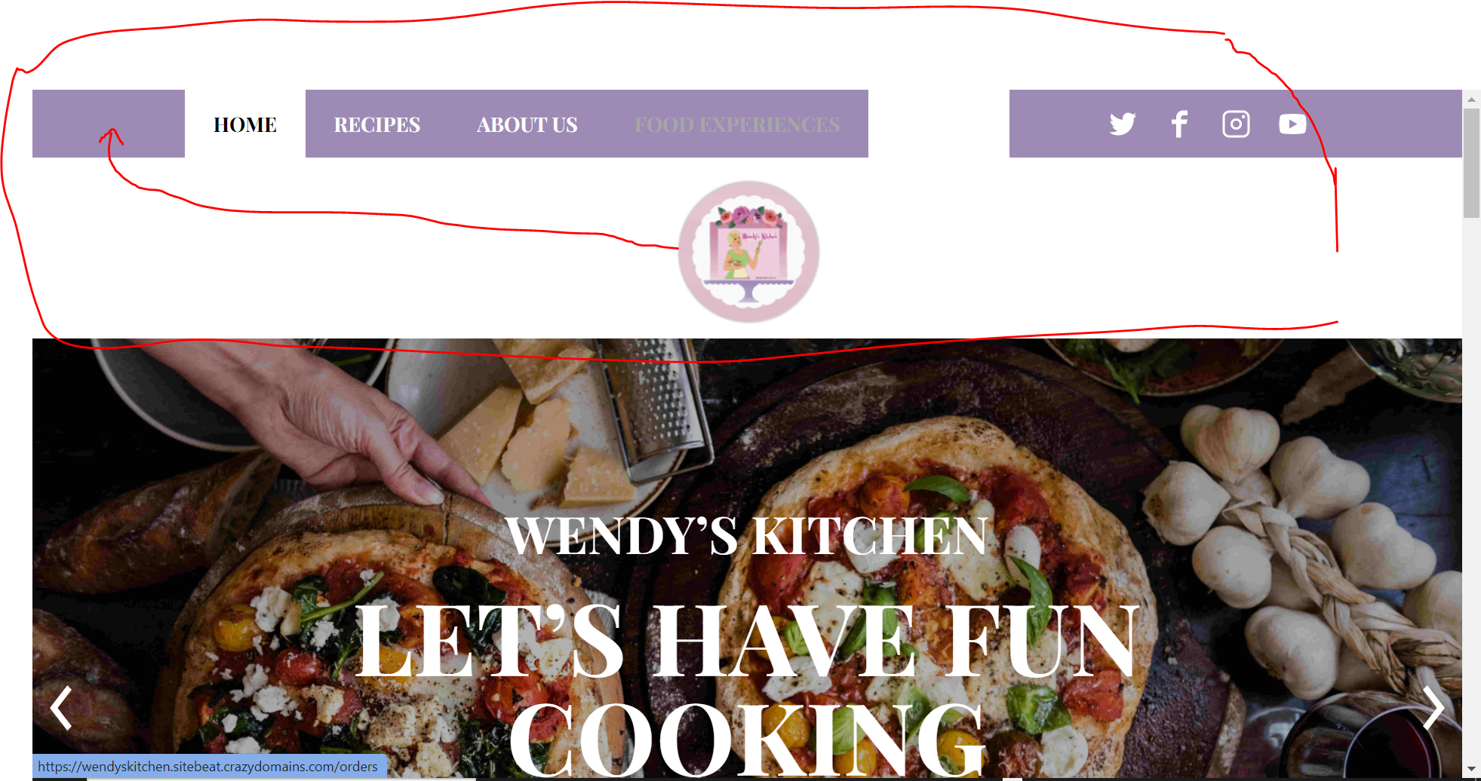

- Make the menu bar larger like Vegkit, it can be bigger, but keep the colour scheme in my logo.
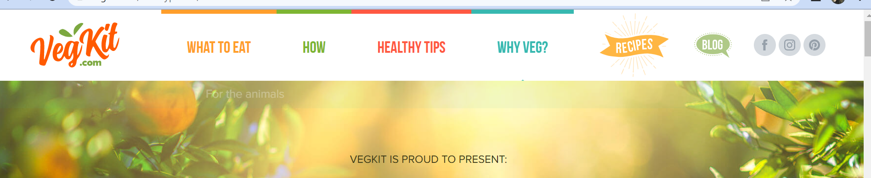

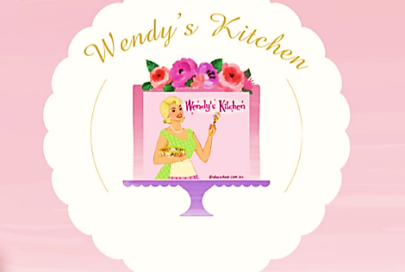
- Use this as my logo on the left-hand side of the menu bar.

- Change Wendy’s Kitchen to larger and Bradley hand font.
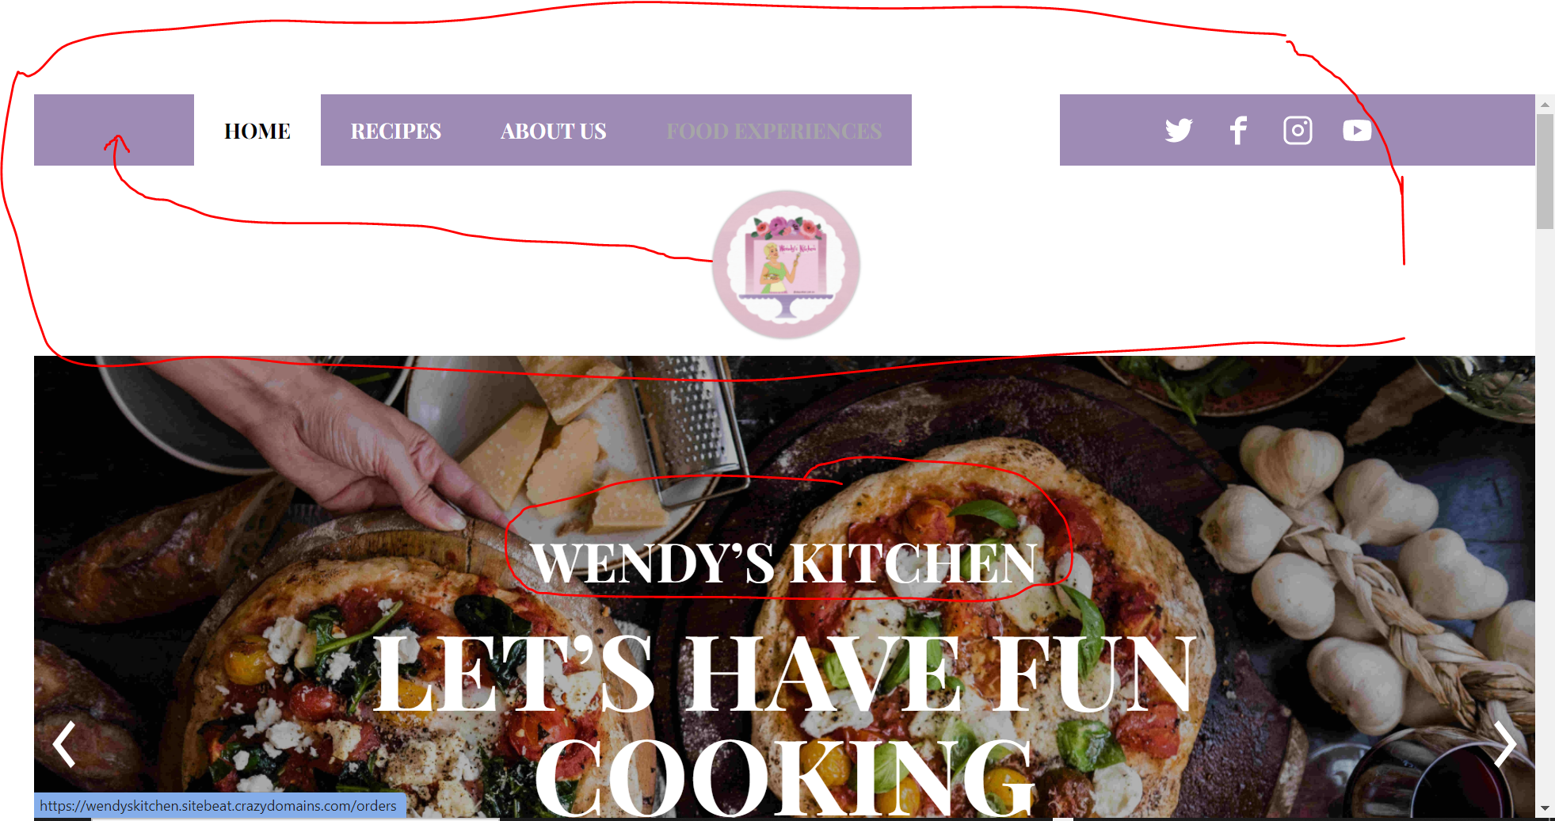

- Change Let’s have fun cooking! to smaller, italic, French script font. 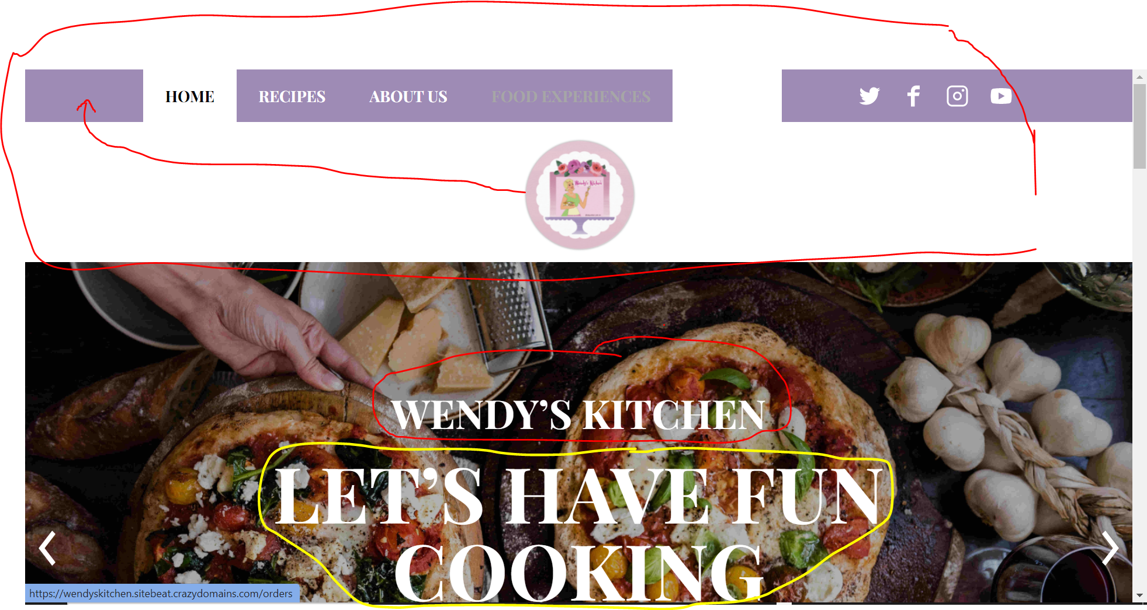

Could it be added on an angle as hand writing similar to this? If yes, I need to have an option to edit later if I don’t like it.

- Reword ‘View our orders’ to ‘Place an order’
- Reword ‘Food experience’ to ‘Submit recipe request’
- Can I remove the phone number?
- Can you explain these tabs please. Are they hyperlinks to pages?
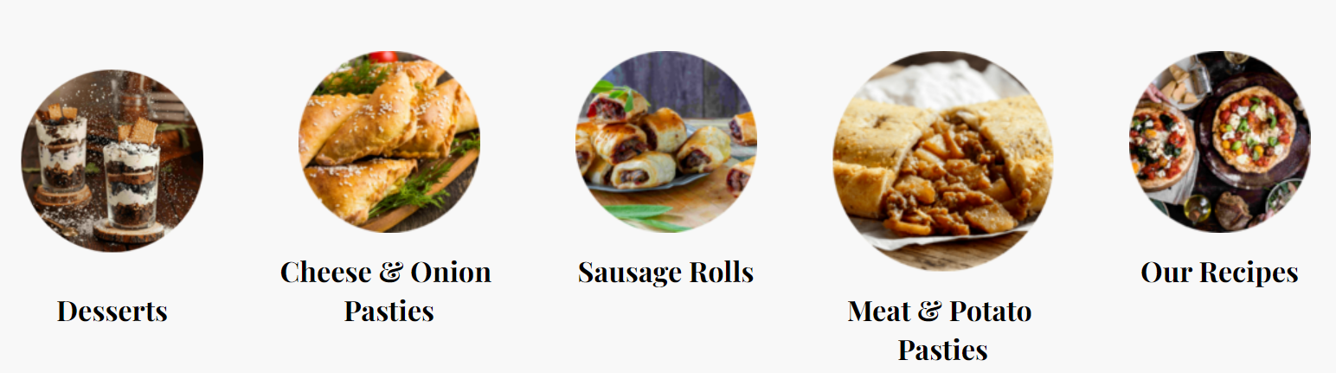

- Recipes Tab
- Will the page have photos for customer to select to view the recipe? Like Sainsburys below.
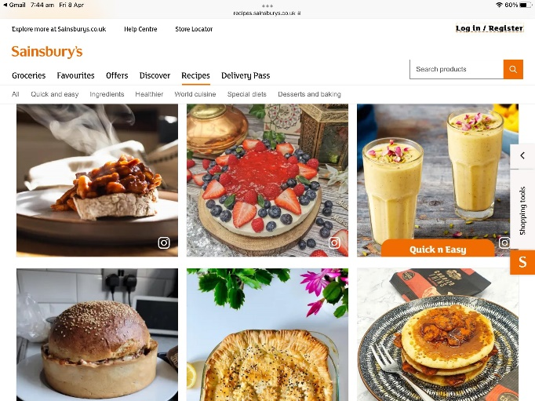

- I would like the recipe layout as provided on the link I gave you below:
https://l.facebook.com/l.php?u=https%3A%2F%2Frecipes.sainsburys.co.uk%2Frecipes%2Froast-potato-and-parsnip-cake&h=AT04Zb90lHdznsMoa7Xj9ji8Z4c4JkDJqoyEjKxjjST6YWGHtSrsZJ7Yc2tU3aKeUZsnpWtS_dQWp3N663GESy4j1adzgKIktD26n1r966vqG36ziRECFgv-wP-RnhaSxvy84a-aHRVlHPI&s=1

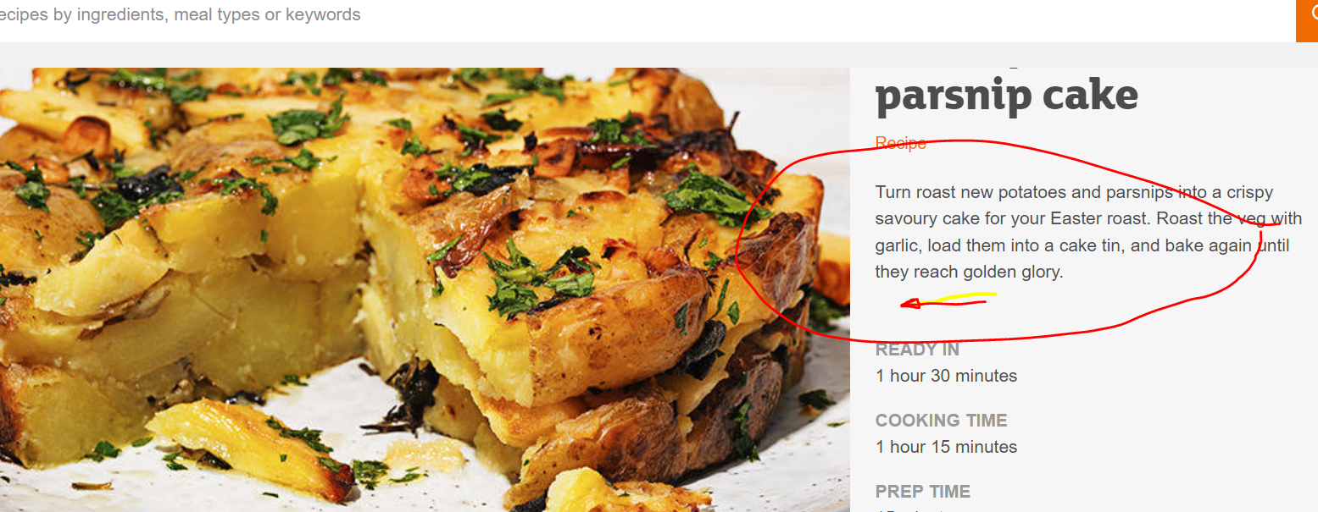
- As per the above layout, is it possible to have a link to the YouTube video with the recipe in the area as highlighted below:

- At the start of each recipe, please put a larger capital letter in French Script and gold on the first letter to Method (see example below).
Will I have the option to change font and colours for future recipes?
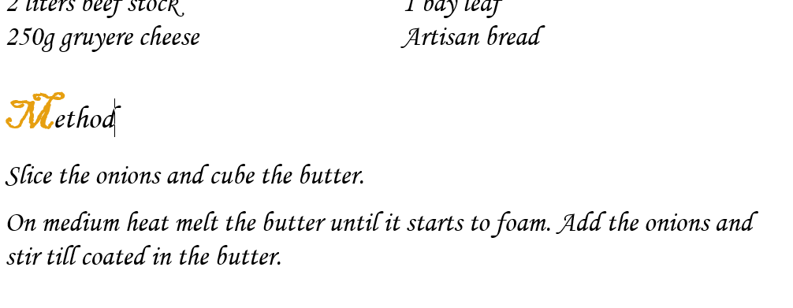
- Food Experience Tab
  - I would like the content under the Food Experience Tab moved to the About Us Tab, under the red marker (as shown below)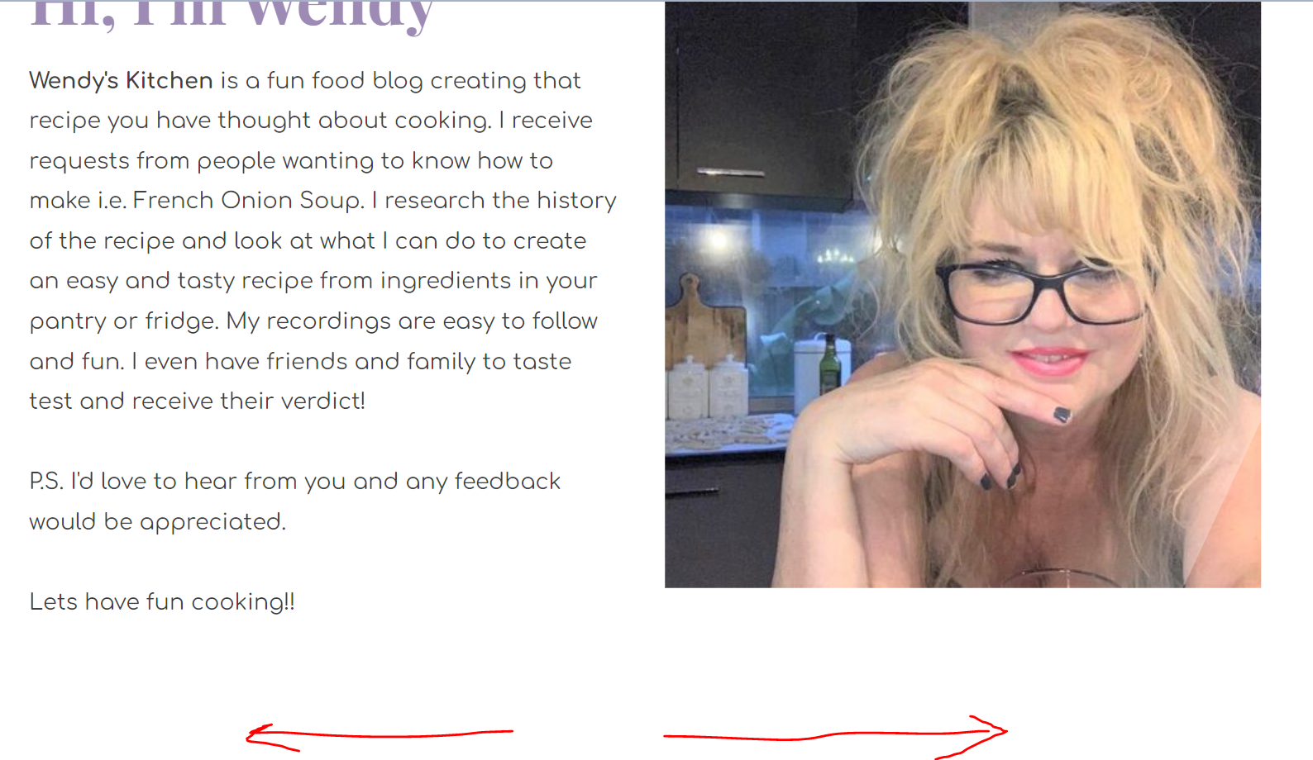

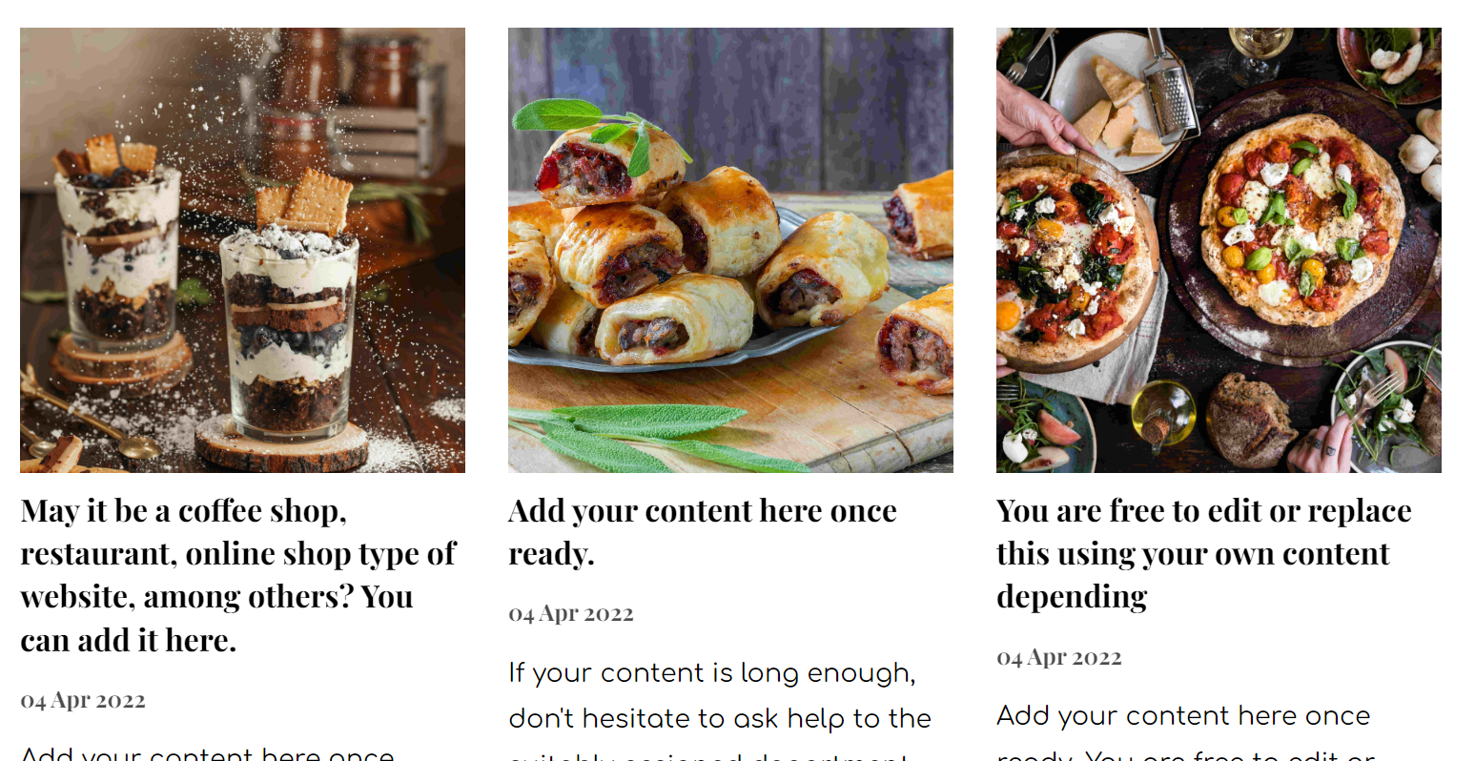

- I would like the Food Experiences tab to be changed to Celebrations.
  - Purpose of tab
    - This tab will have the option to view the recipe that is festive based and/or a link to festive décor ideas on social media, ie Instagram, Facebook, Twitter etc, similar to this website https://www.countryliving.com/easter/
  - Layout
    - So the layout can stay the same but different photos with (a) and (c)
  - Links
    - links to recipes and social media posts, ie Christmas cake, Christmas table setting ideas etc
- Orders Tab
  - Insert ‘Coming Soon’
  - Insert word or PDF Price list Sheet above the Orders submission
    - This must be replaceable
  - Replace Photo with one of my own next to orders submission

